Case 8: Customer Feedback System

Contents

Summary 1

Explanation 1

Project Internal Working 4

Product screens 5

Admin Panel 5

Admin Login screen 6

Admin home screen 6

Summary   
Most of the time, clients are eager to discuss your company. Records, focusing mostly on customer pride, are an essential component for any businesses, no matter how large or little. All of the decision-making at successful firms is based on facts. Businesses rely on financial data to establish price factors, carefully analyze outcomes to determine the best advertising techniques, and most crucially, customer feedback affects almost every aspect of how a successful business functions.

# Explanation

Experts Reveal the Advantages of Customer Feedback  
  
In most cases, customers will gladly brag about your company. Customer feedback is the knowledge people provide when they do chat, and it may help you improve your company in every way. The term "customer feedback" refers to the comments and observations made by consumers after interacting with your business and its offerings.  
  
  
Service Analytics is a part of HubSpot Service Hub that may help you learn more about your service teams. A simple way to find out how your customers feel and keep providing the service they want is to look at their customer satisfaction levels (CSAT).  
  
  
One major advantage of customer feedback is the insight it provides into your target demographic.  
You can bet that your company scoured the web for information about your ideal customers by creating buyer personas and doing thorough market research. While the information you gleaned is likely useful, nothing beats the insight that comes straight from your consumers—that is, customer feedback. (*Customer feedback: 7 advantages & benefits of collecting it*)  
  
What customers anticipate from you, how they utilize your goods and services, and more about themselves will be revealed to you. Get to know them better so you can tailor your encounters to their specific wants and requirements. (*Customer feedback: 7 advantages & benefits of collecting it*)  
  
Additionally, consumers have come to anticipate that the companies they support will be attentive to their requirements and would actively work to meet those demands. As an example:  
  
An overwhelming majority of customers (73%) over the globe want businesses to cater to their individual wants and requirements. (*Customer feedback: 7 advantages & benefits of collecting it*)further than half of customers who have had a customized experience are likely to make further purchases.Personalized experiences result in an average 38% increase in customer spending, according to 80% of company executives. (*Customer feedback: 7 advantages & benefits of collecting it*)  
2. The amount of client satisfaction may be learned from consumer feedback.  
When consumers are content with your company's offerings and their experiences overall, you may say that customer satisfaction is high. It's a crucial measure for resolving customer complaints, avoiding client churn, and establishing a loyal customer base.  
  
Customer satisfaction surveys are one method of gathering specific feedback from consumers that can tell you how happy and pleased they are with your service.Retention rates won't go up if businesses can't gauge client satisfaction, according to Senior client Onboarding Specialist Katie Cort. (*Top 8 benefits of customer feedback* 2022)  
  
advantages of client input  
  
Customer feedback is a great tool for support workers to improve their abilities.  
Customers are more likely to be satisfied with your goods and services if you provide them with good customer assistance. Since it may provide particular insight on rep performance, client feedback is a great tool for making sure your support staff can assist customers in succeeding.  
  
  
This information may be gleaned by sending follow-up questionnaires to consumers following support calls to gauge their level of satisfaction with the assistance they got. This advantage is also mentioned by Rachel Ang, a senior customer support specialist how to be improved.  
In order to better satisfy customer wants and provide great experiences, teams should use consumer feedback to develop and enhance their abilities.  
  
4. Listening to customer input allows you to enhance your offerings.  
Sometimes customers may note a bad experience they've had in their comments. Although it may be discouraging at first, this input may really help you enhance your goods and company operations—particularly if you implement the suggested adjustments. (*Top 8 benefits of customer feedback* 2022)  
  
If a client keeps complaining about a problem with your onboarding process, for instance, it might be a sign that you need to clarify things further or make some changes to make it more efficient.  
  
By soliciting input in this way, you can be confident that your decisions are based on the genuine sentiments and opinions of your most valuable customers, rather than guesswork.  
  
5. Hearing from consumers is a great way to bring in more business.  
When deciding what to buy, many people look to customer reviews, which are a kind of feedback:  
  
Nearly two-thirds of people who read reviews have a favorable impression of the company.  
The data shown above only demonstrate that potential clients are interested in hearing about your business from people who have already done business with you. Gathering and soliciting reviews provides prospective buyers with the information they seek for when making a purchasing decision, which in turn aids in client acquisition. (*Top 8 benefits of customer feedback* 2022)  
  
6. Addressing consumer dissatisfaction begins with gathering input.  
Using customer feedback, you may find out who the unhappy customers are, start a conversation with them, and maybe even reverse the relationship's trajectory by making things right. By sharing their thoughts and feelings about the scenario, you may get insight into the challenges they face and find ways to enhance your operations.  
  
Responding to and resolving consumer complaints increases customer loyalty (83% of consumers agree) therefore it's a good idea to start a conversation with these customers and use their input to make adjustments.

# Project Internal Working

The System of Feedback This is a little PHP project that provides feedback on system performance or corporate services. Both the admin side and the user side of the project are present. The administrator has the ability to read and assess other people's input. The goal of providing feedback is to enhance the performance of the individual or the organization.   
  
The people that submit feedback are the users. Users are able to write and submit feedback that includes their perspective. Users do not need to provide their names, emails, or phone numbers in order to submit. This is a very basic project that provides an easy approach for any firm to assess its products, services, and infrastructure.  
  
  
Concerning the System   
PHP, CSS, and JavaScript are used in this feedback system. In terms of the Feedback system's functions, it just has two sections: an admin part and a user section. The administrator may examine the comments that all users have provided, and the user can offer their own opinions as feedback. This project has a very straightforward design to ensure that the user has no trouble working on it.   
  
How Should the Project Be Managed?   
You need to have installed XAMPP, a virtual server, on your computer in order to operate this project (for Windows). Use this PHP feedback system just for educational purposes. The source code is available for free download.

# Product screens

This home screen of the application and new users can submit their feedback and their feedback will be stored in the database. Every new feedback data will be stored in a new column and one user can submit multiple feedbacks.



# Submission response

# Admin Panel

Admin can see the all details of the user feedback text and can download the reports.

# Admin Login screen

# Admin home screen



Feeback index.php



Admin index.php

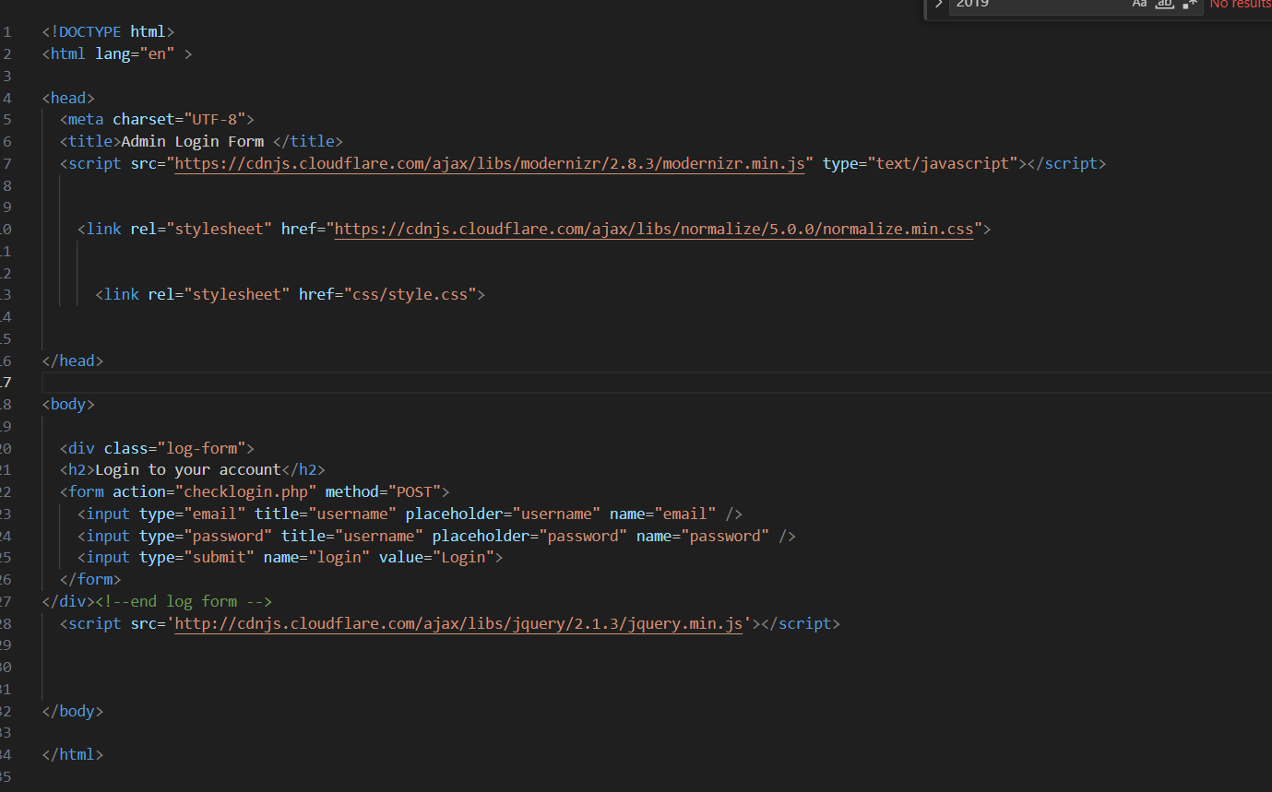

Submitfeedback.php

Second part

Download report

# Poll db table data

Admin user email and password data in db   
  
New Feedbacks   
  


Conclusion

You may find out precisely how your consumers feel and how pleased they are by using specific methods of gathering feedback, such as customer satisfaction surveys. Businesses of all stripes use customer satisfaction metrics to gauge how satisfied their customers are with different aspects of their service. Whether it's streamlining the return process or making online transactions easier, agencies are clearly putting a lot of effort into providing outstanding customer service.

# Refences:

1. *Customer feedback: 7 advantages & benefits of collecting it* (no date) *Customer Feedback: 7 Advantages & Benefits of Collecting It*. Available at: https://www.hotjar.com/customer-feedback/benefits/ (Accessed: 21 May 2024).
2. *Top 8 benefits of customer feedback* (2022) *MonkeyLearn Blog*. Available at: https://monkeylearn.com/blog/customer-feedback-benefits/ (Accessed: 21 May 2024).